

School of Computer Science and Engineering

(Computer Science & Engineering)

Faculty of Engineering & Technology

Jain Global Campus, Kanakapura Taluk - 562112  
Ramanagara District, Karnataka, India

**2024-2025**

**( VII Semester)**

A Project Report on

“Skill-Quest”

Submitted in partial fulfilment for the award of the degree of

Bachelor of Technology

in

COMPUTER Engineering – Software Engineering

Submitted by

Sushmitha S- 21BTRSE047

Under the guidance of

**Mr. Karthikeyan S**

Associate Professor

Department of Computer Engineering – Software Engineering

School of Computer Science & Engineering

Faculty of Engineering & Technology

JAIN (Deemed to-be University)

Department of Computer Engineering – Software Engineering

School of Computer Science & Engineering

Faculty of Engineering & Technology

Jain Global Campus, Kanakapura Taluk - 562112  
Ramanagara District, Karnataka, India

CERTIFICATE

This is to certify that the project work titled **“Skill-Quest”** is carried out by **Sushmitha S (21BTRSE047)** a bona fide student of Bachelor of Technology at the School of Engineering & Technology, Faculty of Engineering & Technology, JAIN (Deemed-to-be University), Bangalore in partial fulfilment for the award of degree in Bachelor of Technology in Computer Science and Engineering, during the year **2024‑2025**.

|  |  |  |
| --- | --- | --- |
| **Mr. Karthikeyan S** | **Dr. Santhosh S** | **Dr. Geetha G** |
| Assistant Professor  Dept. of CS&E,    Date: 26-11-2024 | ProgramHead, Computer Science and Engineering,  School of Computer Science & Engineering  Faculty of Engineering & Technology  JAIN (Deemed to-be University)  Date: 26-11-2024 | Director,  School of Computer Science & Engineering  Faculty of Engineering & Technology  JAIN (Deemed to-be University)  Date: 26-11-2024 |

Name of the Examiner Signature of Examiner

1.

2.

<

DECLARATION

I, **Sushmitha S (21BTRSE047),** student of 7th semester B.Tech in **Computer Engineering Software Engineering**, at School of Engineering & Technology, Faculty of Engineering & Technology, **JAIN (Deemed to-be** **University)**, hereby declare that the In-House Project work titled **“Skill-Quest”** has been carried out by me and submitted in partial fulfilment for the award of degree in **Bachelor** **of Technology in Computer Engineering – Software Engineering** during the academic year **2024‑2025**. Further, the matter presented in the work has not been submitted previously by anybody for the award of any degree or any diploma to any other University, to the best of my knowledge and faith.

|  |  |
| --- | --- |
| Name: Sushmitha S  USN : 21BTRSE0347 | Signature |
|  |  |
|  |  |
|  |  |
|  |  |
| Place : Bangalore  Date : 26-11-2024 |  |

ABSTRACT

The **Skill-Quest** project is an innovative platform designed to enhance the development of soft skills in students through an interactive and user-friendly web interface. It serves two main user groups: teachers and students. The teacher's dashboard allows for the storage and management of student data, including soft skills assessments. Teachers can monitor individual student progress and suggest personalized recommendations to improve their soft skills. The student’s dashboard, on the other hand, enables students to view their details, including soft skills performance, and track their progress through visual graphs. The platform also includes a feature where students can receive course recommendations tailored to improving their soft skills. A key feature of the system is the option for students with a soft skills percentage below 50% to contact their faculty through an integrated email system, facilitating direct communication for additional support. Built using Python and web technologies (HTML, CSS, JavaScript), the project utilizes local storage for data management, making it a suitable prototype for future expansions. **Skill-Quest** aims to bridge the gap between academic learning and essential life skills, fostering the holistic development of students, preparing them for success in both professional and personal domains. Future improvements will include database integration for more robust data management.

**Index**

1. **Introduction**
2. **Project Overview**
3. **Functionalities**
   * Teacher's Dashboard
   * Student's Dashboard
4. **Technologies Used**
5. **Implementation**
   * HTML, CSS, JavaScript
   * Python Integration with Jupyter Notebook
6. **User Interaction**
7. **Challenges Faced and Solutions**
8. **Future Enhancements**
9. **References**
10. **Appendix**
11. **Conclusion**

**1. Introduction**

The **Skill-Quest** project is a comprehensive platform aimed at enhancing the soft skills development of students through the use of digital tools. Soft skills, including communication, leadership, problem-solving, and teamwork, are vital for students' overall growth, helping them succeed not only academically but also in their professional and personal lives. Recognizing the importance of these skills, **Skill-Quest** provides an interactive interface for both teachers and students, helping bridge the gap between academic knowledge and the soft skills required in the real world.

The project leverages a web-based interface where teachers can track and monitor the progress of their students in terms of soft skills development. It also offers personalized feedback and actionable suggestions for students, allowing them to take charge of their improvement. With features like progress tracking graphs, soft skill assessment, and faculty communication tools, **Skill-Quest** aims to make soft skills development an engaging and integral part of students’ learning journeys.

**2. Project Overview**

**Skill-Quest** is designed with two main interfaces: one for teachers and one for students. These interfaces serve distinct but complementary purposes in the ecosystem. On the teacher's side, the platform provides the tools needed to record and manage student data, particularly related to their soft skill assessments. Teachers can input details like a student’s name, progress percentage, and categorize their performance based on soft skill areas such as communication, leadership, and problem-solving. This data is then displayed on the student’s dashboard, where students can access it and understand how they are progressing in different skill areas.

The student's dashboard offers an interactive experience where students can view their progress, receive course recommendations, and track their improvement over time. If a student's performance is below a set threshold (e.g., less than 50%), the system automatically provides a suggestion to meet with a faculty member, facilitating timely intervention. Additionally, the students can use an integrated email feature to request meetings with their faculty directly from the dashboard.

The project’s key objective is to create a holistic tool that allows both students and teachers to engage in a constructive feedback loop that supports the continuous development of soft skills, an area that is often overlooked in traditional academic systems.

**3. Functionalities**

**Teacher's Dashboard**

The Teacher’s Dashboard is designed to facilitate the entry and tracking of student data related to soft skills. Teachers can log the progress of each student by entering their **USN**, name, and soft skills percentages. This information is stored locally in the browser, making it easy for the teacher to access and update as needed.

One of the key features of the teacher’s dashboard is the ability to view a list of all students whose data has been entered. This list can be accessed easily, and teachers can click on any student to view detailed progress information. If a student's soft skill progress is below 50%, a warning is displayed, prompting the teacher to take further action. This feature ensures that teachers can easily monitor students who may need additional support.

The teacher’s dashboard also allows teachers to send emails to students, particularly those who need to be notified about their performance. Additionally, the dashboard has a feature to send reminders or alerts to students, encouraging them to improve their soft skills if their progress is lagging.

**Student's Dashboard**

The Student’s Dashboard is designed to provide an intuitive, user-friendly experience for students. When students log into the platform, they can simply enter their **USN** to fetch their details. The system displays their name and soft skills progress percentage. If a student's progress is below 50%, the system automatically displays a message prompting them to meet with their faculty for guidance and support.

One of the main features on the student dashboard is the ability to send an email to the faculty member requesting a meeting. This functionality is particularly important for students who are struggling to improve their soft skills. The email is pre-filled with a message that conveys the student’s concern about their performance and requests a meeting for improvement. This feature ensures that students are proactive about seeking help and take ownership of their development.

The dashboard also offers students recommendations for online courses or resources that can help them improve specific areas of soft skills. This personalized approach ensures that students are provided with the tools they need to progress and gain proficiency in the required skills.

**4. Technologies Used**

The **Skill-Quest** project is built using a combination of technologies that are well-suited to the web-based nature of the application. **HTML** serves as the backbone of the project, providing the structural layout for both the teacher's and student’s dashboards. The HTML code is responsible for creating various elements such as input fields, buttons, and links, which allow the user to interact with the platform.

To enhance the visual appeal and ensure a smooth user experience, **CSS** is used extensively throughout the project. It is responsible for styling the different components of the dashboard, ensuring that the buttons are clearly visible, the text is readable, and the overall design is both aesthetically pleasing and functional. The color scheme primarily uses shades of blue, providing a calming and professional atmosphere.

**JavaScript** plays a crucial role in making the platform interactive. It is used to handle user inputs, such as the entry of a student's **USN** to fetch their data, and to display the corresponding information dynamically. Additionally, JavaScript handles the logic for checking the student’s progress and determining if they need to meet with faculty. The **window.open()** function is used to open Gmail in a new tab for sending emails directly to the faculty.

On the back end, the project makes use of **Python** to run the application inside a **Jupyter Notebook** environment. Jupyter allows the integration of both the front-end and back-end components, making it easy to test and prototype the project in a single environment.

Local storage is used to temporarily store student data in the browser, making it easy to test the application without setting up a full-fledged database system. As the project is still in its prototype phase, local storage provides an efficient way to maintain data persistence during user sessions.

**5. Implementation**

The implementation of **Skill-Quest** involves creating an interactive web application that integrates front-end and back-end technologies seamlessly. The front-end is developed using **HTML**, **CSS**, and **JavaScript**, which together form the user interface for both the teacher’s and student’s dashboards.

The teacher’s dashboard allows teachers to input and track student data, while the student’s dashboard provides an intuitive platform for students to view their soft skills progress. JavaScript is used to create dynamic interactions, such as fetching data based on a student’s **USN** and displaying a progress graph. If the progress is low, the system prompts the student to request a faculty meeting via email.

The use of **Jupyter Notebook** for running the project allows for an integrated development environment where both the front-end and back-end can be tested and executed in a single platform. This makes it easier to simulate how the application would function in a real-world scenario without needing a separate server-side setup.

**6. User Interaction**

In terms of user interaction, the system is designed to be straightforward and easy to navigate for both students and teachers. Teachers enter data such as student names and progress percentages, which are stored in local storage. This data is then used by the student’s dashboard to display relevant information.

For students, the experience is centered around entering their **USN** to fetch their data and viewing their progress on a simple interface. If the student’s progress is below the required threshold, they are automatically prompted to meet with a faculty member. The "Request Faculty Meeting" feature allows students to send an email to the faculty directly from the platform, ensuring that communication is seamless.

The progress graph provides students with a visual representation of their soft skills development over time, encouraging them to track their improvement and take proactive steps toward bettering their skills.

**7. Challenges Faced and Solutions**

One of the major challenges in developing **Skill-Quest** was ensuring the persistence of data between user sessions. Given that the project is a prototype, we used **local storage** to store data temporarily, which solved the issue of data persistence within the same browser session. However, for future enhancements, integrating a database would be a more robust solution.

Another challenge was ensuring that the email integration functioned correctly. Initially, the email requests were not opening in the web version of Gmail as expected. This issue was resolved by carefully using the **Gmail compose URL**, which opens a new tab directly in the Gmail web interface.

Additionally, creating an aesthetically pleasing and user-friendly design while maintaining functionality was an ongoing challenge. The use of **CSS** for styling, including responsive layouts and a consistent color scheme, helped overcome this challenge and provided a balanced user experience.

**8. Future Enhancements**

While the current version of **Skill-Quest** offers the essential functionalities, there are several ways it could be expanded and improved. A more robust back-end could be implemented by integrating a database such as **MySQL** or **MongoDB** to store student data persistently. This would allow for data to be accessible across different sessions and provide better scalability for the application.

Additionally, the platform could benefit from more advanced features, such as student authentication and role-based access control. This would ensure that only authorized users can access certain features, enhancing the security of the system.

Further, the soft skills assessment could be expanded to include additional categories, such as emotional intelligence, conflict

resolution, and collaboration skills. This would provide a more comprehensive view of a student’s growth in terms of soft skills.

1. **References**
2. **Soft Skills and Their Importance in Education and Employment**
   1. **NACE (National Association of Colleges and Employers)**. (2019). *The Job Outlook 2019 Survey*. National Association of Colleges and Employers.  
      This report highlights the growing demand for soft skills among college graduates and outlines the importance of communication, problem-solving, and leadership skills in professional settings.  
      [Link](https://www.naceweb.org)
3. **Soft Skills Development in Education**
   1. **Robles, M. M.** (2012). *Executive Perceptions of the Top 10 Soft Skills Needed in Today's Workplace*. Business Communication Quarterly, 75(4), 453-465.  
      This paper discusses the critical soft skills employers look for in employees and how these skills impact success in the workplace. The study shows that employers prioritize soft skills, especially communication and leadership, which are important for student development. DOI
4. **Technology Integration in Education**
   1. **Ng, W.** (2012). *Can We Teach Digital Natives Digital Literacy?*. Computers & Education, 59(3), 1065-1078.  
      This study explores how digital tools and technology can be integrated into the classroom to enhance learning and soft skills development. The research discusses the role of e-learning platforms in bridging knowledge gaps and empowering students with essential 21st-century skills.  
      DOI
5. **Developing Soft Skills Through Web-Based Learning**
   1. **Aydin, S.**, & **Tuncer, B.** (2020). *The Impact of Web-Based Learning Systems on Soft Skill Development in Higher Education*. Journal of Educational Technology & Society, 23(3), 1-15.  
      This article reviews the use of web-based learning systems in developing soft skills such as communication, leadership, and teamwork. It examines how online platforms can enhance traditional educational methods and provide personalized feedback for skill development.  
      Link
6. **E-Learning and Soft Skills in Higher Education**
   1. **Samsudin, Z., & Majid, M. S. A.** (2020). *Integrating Soft Skills in E-Learning Platforms: A Study on the Design and Implementation of Web-Based Soft Skills Modules*. Procedia Computer Science, 172, 104-111.  
      This paper focuses on the integration of soft skills in e-learning platforms, presenting case studies of universities that have implemented web-based modules for soft skills development, specifically communication, problem-solving, and adaptability.  
      DOI
7. **Impact of Soft Skills on Academic and Professional Success**
   1. **Goleman, D.** (1995). *Emotional Intelligence: Why It Can Matter More Than IQ*. Bantam Books.  
      Goleman’s work on emotional intelligence provides an in-depth look at how emotional regulation, empathy, and other soft skills contribute to both personal and professional success. This book is a foundational text in understanding the psychological components of soft skills development.
8. **The Role of Teachers in Developing Soft Skills**
   1. **Kaufman, R. A., & Kaufman, P. B.** (2012). *Skills Development in Higher Education: A Comprehensive Approach*. International Journal of Educational Development, 32(2), 196-205.  
      This paper explores how teachers can foster the development of soft skills in students, emphasizing the need for active teaching strategies, feedback mechanisms, and the role of educational institutions in nurturing these skills alongside academic knowledge.  
      DOI
9. **Soft Skills Training in Higher Education: A Global Perspective**
   1. **Kunzmann, U.**, & **Richter, T.** (2018). *Enhancing Soft Skills for Global Success: Education and Training for Students in the Global Economy*. Springer.  
      This book covers the importance of soft skills in the context of globalization and how educational institutions are shifting towards holistic education to equip students with the necessary skills to thrive in a global economy.
10. **Development of Soft Skills in Online Learning Environments**
    1. **Nicol, D.** (2014). *The Role of Feedback in Developing Student Soft Skills*. Assessment & Evaluation in Higher Education, 39(2), 120-134.  
       This article discusses how feedback in an online learning environment can foster the development of soft skills. It focuses on peer-to-peer interactions, instructor feedback, and how these components influence student growth in areas such as communication and teamwork.
11. **Interactive Learning Platforms for Soft Skills Development**
    1. **Kavitha, R., & Venkatesh, S.** (2019). *Gamification in Soft Skills Training: Benefits and Challenges*. Journal of Educational Technology & Society, 22(4), 95-106.  
       This paper looks at the integration of gamification in web-based learning environments, examining how it helps engage students in developing soft skills. It discusses the effectiveness of interactive learning platforms in promoting skills such as critical thinking and leadership.
12. **Appendix**

**Code:**

**Skillquest-teacher.html**

<!DOCTYPE html>

<html lang="en">

<head>

<meta charset="UTF-8">

<meta name="viewport" content="width=device-width, initial-scale=1.0">

<title>Teacher's Dashboard - SkillQuest</title>

<style>

body {

font-family: Arial, sans-serif;

background-color: #f0f4f8;

color: #333;

}

.container {

max-width: 600px;

margin: 50px auto;

padding: 20px;

background-color: white;

border-radius: 8px;

box-shadow: 0 0 10px rgba(0, 0, 0, 0.1);

}

.button {

background-color: #4a90e2;

color: white;

padding: 10px 20px;

border: none;

border-radius: 5px;

cursor: pointer;

}

.button:hover {

background-color: #357ab7;

}

.student-list {

margin-top: 20px;

padding: 10px;

background-color: #eaf1f8;

border-radius: 5px;

box-shadow: 0 0 5px rgba(0, 0, 0, 0.1);

}

.student-list ul {

list-style-type: none;

padding: 0;

}

.student-list li {

margin: 5px 0;

}

</style>

</head>

<body>

<div class="container">

<h2>Teacher's Dashboard</h2>

<label for="usn">Enter Student USN:</label><br>

<input type="text" id="usn" placeholder="Enter USN"><br><br>

<label for="name">Student Name:</label><br>

<input type="text" id="name" placeholder="Enter Name"><br><br>

<label for="softskills">Soft Skills Progress (0-100):</label><br>

<input type="number" id="softskills" placeholder="Enter Progress" max="100"><br><br>

<button class="button" onclick="storeData()">Store Data</button>

<br><br>

<button class="button" onclick="viewAllStudents()">View All Students</button>

<div id="studentList" class="student-list" style="display: none;">

<h3>All Students</h3>

<ul id="studentListContent"></ul>

</div>

</div>

<script>

function storeData() {

var usn = document.getElementById('usn').value;

var name = document.getElementById('name').value;

var softskills = document.getElementById('softskills').value;

if (usn && name && softskills) {

var studentData = {

"name": name,

"softskills": softskills

};

localStorage.setItem(usn, JSON.stringify(studentData));

alert("Data stored successfully!");

} else {

alert("Please fill all fields!");

}

}

function viewAllStudents() {

var studentList = document.getElementById('studentList');

var studentListContent = document.getElementById('studentListContent');

studentListContent.innerHTML = ''; // Clear existing list

var studentsFound = false;

for (var i = 0; i < localStorage.length; i++) {

var key = localStorage.key(i);

var studentData = JSON.parse(localStorage.getItem(key));

if (studentData && studentData.name && studentData.softskills !== undefined && studentData.softskills !== null) {

var listItem = document.createElement('li');

listItem.textContent = "USN: " + key + " | Name: " + studentData.name + " | Soft Skills: " + studentData.softskills + "%";

studentListContent.appendChild(listItem);

studentsFound = true;

}

}

// Show the list if there are valid students

if (studentsFound) {

studentList.style.display = 'block';

} else {

studentList.style.display = 'none';

alert('No valid student data found!');

}

}

</script>

</body>

</html>

**Skillquest-student.html**

<!DOCTYPE html>

<html lang="en">

<head>

<meta charset="UTF-8">

<meta name="viewport" content="width=device-width, initial-scale=1.0">

<title>Student's Dashboard - SkillQuest</title>

<style>

body {

font-family: Arial, sans-serif;

background-color: #f0f4f8;

color: #333;

}

.container {

max-width: 600px;

margin: 50px auto;

padding: 20px;

background-color: white;

border-radius: 8px;

box-shadow: 0 0 10px rgba(0, 0, 0, 0.1);

}

.button {

background-color: #4a90e2;

color: white;

padding: 10px 20px;

border: none;

border-radius: 5px;

cursor: pointer;

}

.button:hover {

background-color: #357ab7;

}

.graph-container {

margin-top: 20px;

}

.alert {

margin-top: 20px;

padding: 10px;

background-color: #ffcc00;

color: white;

border-radius: 5px;

box-shadow: 0 0 5px rgba(0, 0, 0, 0.1);

}

</style>

</head>

<body>

<div class="container">

<h2>Student's Dashboard</h2>

<label for="usn">Enter Your USN:</label><br>

<input type="text" id="usn" placeholder="Enter USN"><br><br>

<button class="button" onclick="fetchData()">Fetch Details</button>

<div id="studentDetails"></div>

<div id="alertMessage" class="alert" style="display: none;">

<p>Your soft skills progress is below 50%. Please meet your faculty for further guidance.</p>

<button class="button" onclick="sendEmail()">Request Meeting with Faculty</button>

</div>

<div class="graph-container" id="graphContainer"></div>

</div>

<script>

function fetchData() {

var usn = document.getElementById('usn').value;

var studentData = JSON.parse(localStorage.getItem(usn));

if (studentData) {

document.getElementById('studentDetails').innerHTML = `

<h3>Name: ${studentData.name}</h3>

<p>Soft Skills Progress: ${studentData.softskills}%</p>

`;

// Show alert if progress is less than 50

if (studentData.softskills < 50) {

document.getElementById('alertMessage').style.display = 'block';

}

// Show progress graph

showProgressGraph(studentData.softskills);

} else {

alert("No data found for this USN!");

}

}

function showProgressGraph(progress) {

var ctx = document.createElement('canvas');

document.getElementById('graphContainer').appendChild(ctx);

var chart = new Chart(ctx, {

type: 'line',

data: {

labels: ['Week 1', 'Week 2', 'Week 3', 'Week 4'],

datasets: [{

label: 'Soft Skills Progress',

data: [progress, progress + 10, progress + 20, progress + 30], // Sample progress data

borderColor: '#4a90e2',

backgroundColor: 'rgba(74, 144, 226, 0.1)',

fill: true

}]

},

options: {

scales: {

y: {

beginAtZero: true

}

}

}

});

}

function sendEmail() {

var facultyEmail = "faculty@example.com"; // Replace with the actual faculty email

var subject = "Request for Meeting - Soft Skills Progress";

var body = "Dear Faculty,\n\nI am a student with USN: " + document.getElementById('usn').value +

" and my soft skills progress is below 50%. I would like to request a meeting to discuss ways I can improve.\n\nThank you.";

window.location.href = `mailto:${facultyEmail}?subject=${encodeURIComponent(subject)}&body=${encodeURIComponent(body)}`;

}

</script>

<script src="https://cdn.jsdelivr.net/npm/chart.js"></script>

</body>

</html>

**Snapshots**

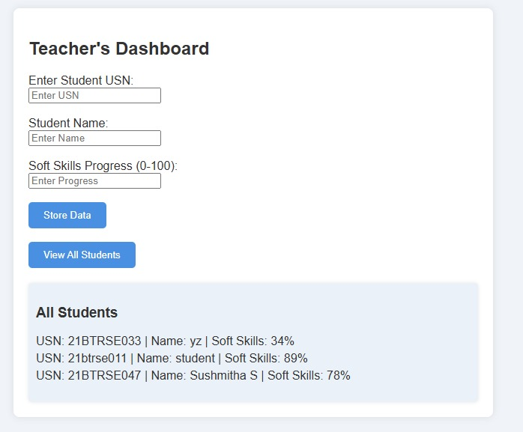

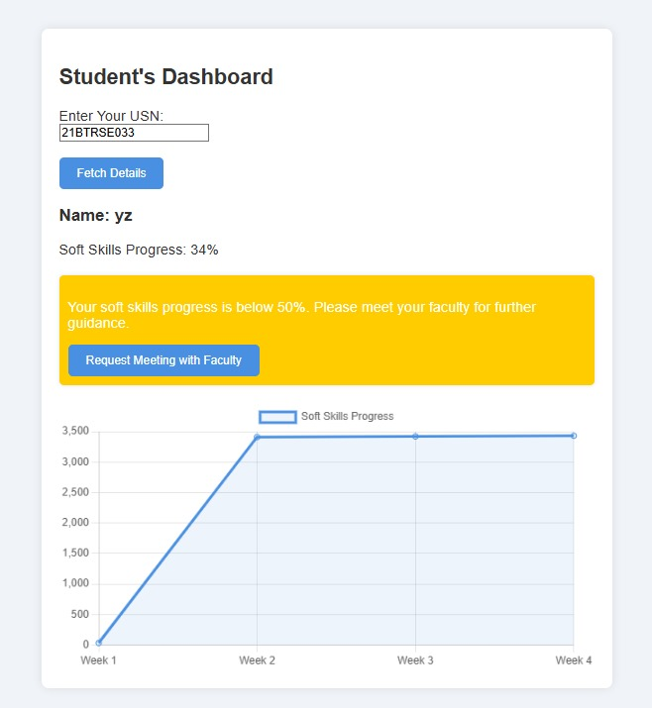

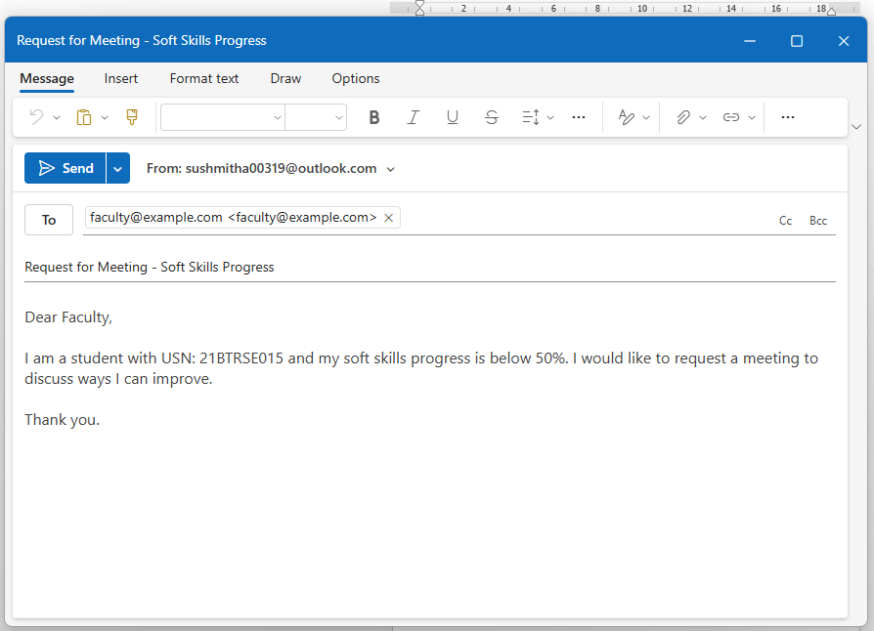

**11. Conclusion**

Skill-Quest is a promising platform that addresses the growing need for soft skills development in students. By providing an easy-to-use interface for both students and teachers, it aims to bridge the gap between academic knowledge and practical, real-world skills. With its focus on improving communication, leadership, and problem-solving abilities, Skill-Quest helps students become well-rounded individuals who are prepared to succeed in their careers and beyond. Future enhancements, including database integration and expanded features, will further improve the platform’s capabilities, ensuring that it remains a valuable tool for soft skills development.